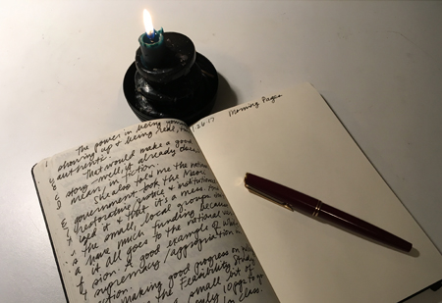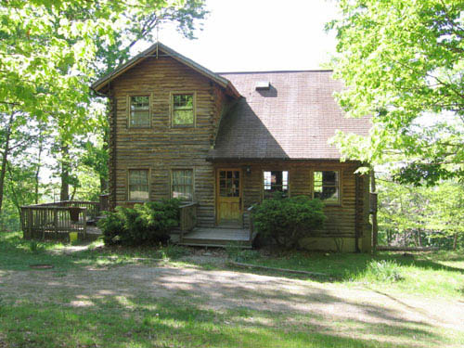

“You were made and set here to give voice to this, your own astonishment.”

—Annie Dillard

At its best, writing is an active process of discovery, often surprise. You might start out with one idea, only to be detoured in another direction entirely. In a very real sense, we write to discover what we think and feel. Writing allows us to give voice to the unseen around and within us.

This retreat is an opportunity to come together with fellow lovers of writing in an impromptu community that includes ceremony, journaling, free-writing, sharing, solo wanders on the land, active listening, storytelling, nourishing meals, and other soulful activities.

Join us to

* Discover your ability to hear and transcribe messages from subtle sources
* Practice ways to be still, connect, and listen
* Enjoy time on the land, in communion with the living breathing world
* Feel the freedom of tapping into an unlimited source of reassurance, ideas, love, and stories
* Experience yourself as a channel for hidden wisdom
* Honor your unique voice and role in bringing forth the inspiration that is so needed in these times

“The act of writing is an act of optimism. You would not take the trouble to do it if you felt it didn’t matter.”

—Edward Albee

Writing from the soul

# May 19-21, 2017 at The Nest Retreat near Rolling Ridge

Harpers Ferry, WV

Adjoining the Rolling Ridge Foundation Wilderness Preserve, the four bedroom Nest cabin is near the bank of the Shenandoah River. Additional lodging at Full Circle Hospitality House. The retreat is led by Julie Gabrielli with assistance from Joy Bauer and hosted by Lindsay McLaughlin.

$199 (single occupancy); or sign up with a friend or partner and pay reduced fee of $149 each; camping is $139 (bring your own tent).

Register at www.friendsofsilence.net/events.

